Real Time River Water Quality Monitoring and Control System Team ID : PNT2022TMID17030

Develop A Web Application Using Node-RED Service.

Step 1: Develop The Web Application Using Node-RED

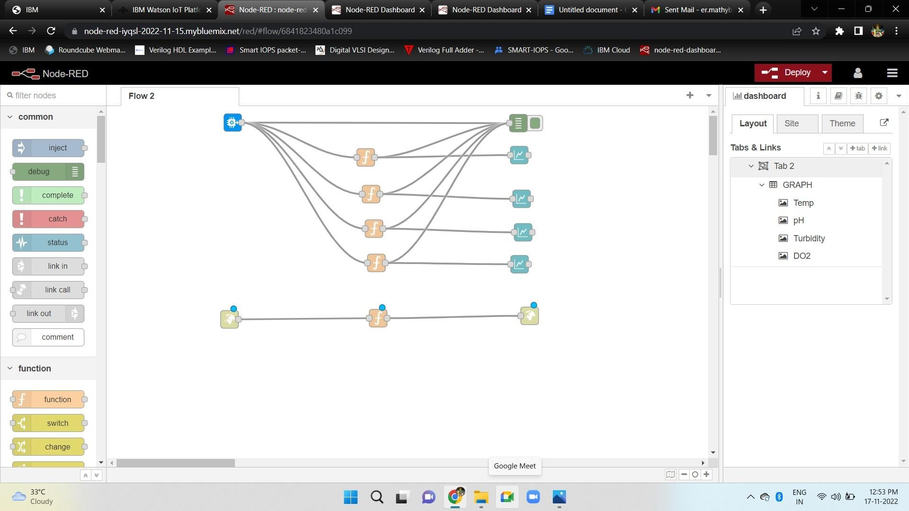

Step 2: Use Dashboard Nodes For Creating UI(Web App)

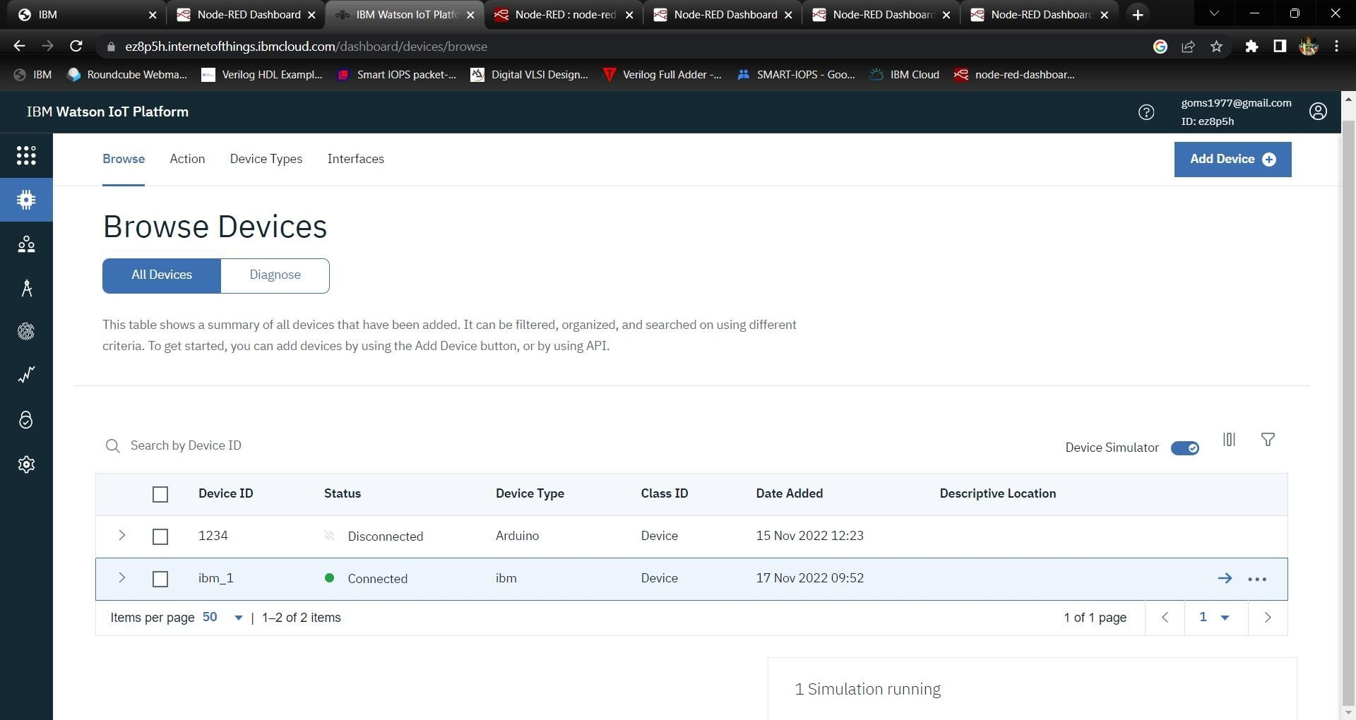

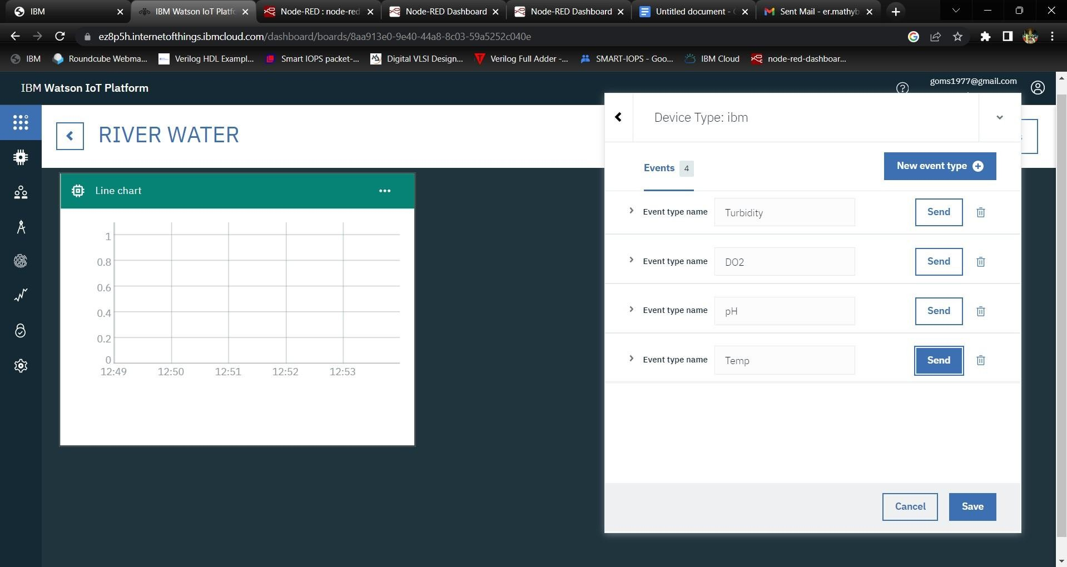

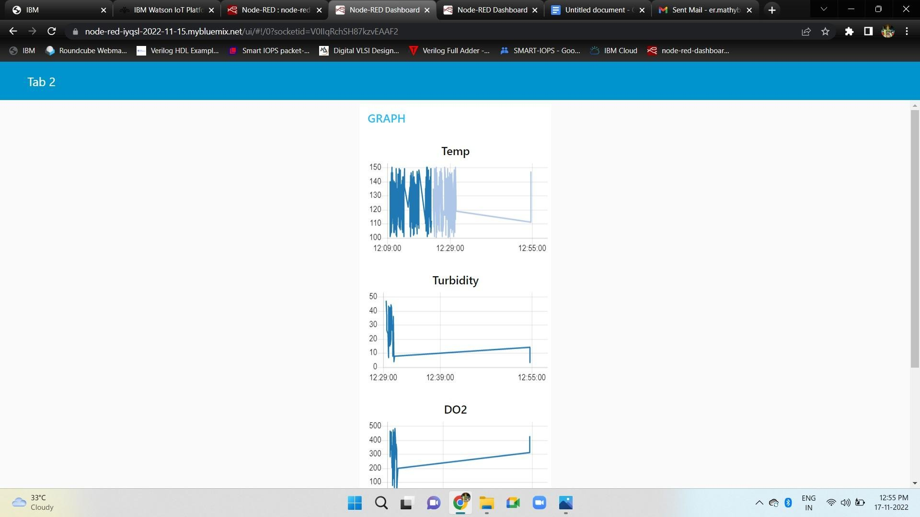Output

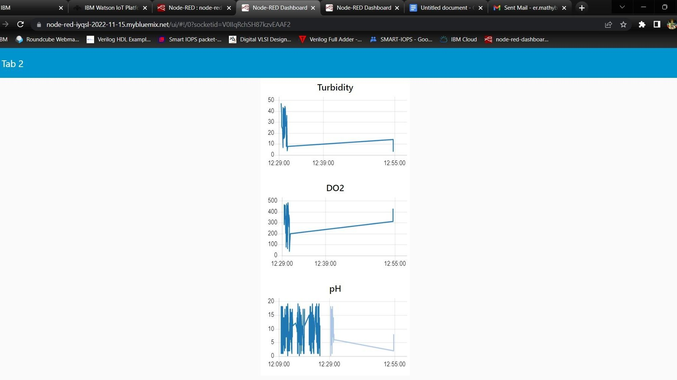

Step 3: Create An HTTP Requests To Communicate With Mobile App

